Report for DACS Contract Corresponding author:

**(Project Number 00123945)** Jonathan F. Day

Florida Medical Entomol. Lab,

Running head: Arbovirus Surveillance Program 200 9th St. SE, Vero Beach,

Florida 32962, USA

Phone: (772) 778-7200 x 132

Fax: (772) 778-7205

E-mail: jfda@ufl.edu

Implementation of a Comprehensive and Sustainable Arbovirus

Surveillance Program at the County Level

Jonathan F. Day and Gregory K. Ross

University of Florida, IFAS, Florida Medical Entomology Laboratory, 200 9th St. SE, Vero Beach, FL 32962

**ABSTRACT**

New technologies have come online recently that have the potential of enhancing local arboviral surveillance efforts and the forecasting of arboviral transmission events. These technologies utilize a host of environmental data including Doppler radar-based total precipitation and Keetch Byram Drought Indexing (KBDI), both at a 4 km2 resolution and MOSIAC modeling at an 11 km2 resolution. These three environmental models have yet to be integrated into a single local arboviral surveillance protocol. During the 2014 arboviral transmission season 36 sentinel chicken seroconversions, three EEE equine cases, and four West Nile human cases were reported by the Volusia County Mosquito Control (VCMC). The majority of the seroconversions occurred between July and September. Seroconversions were reported at all 13 sentinel chicken sites maintained by VCMC suggesting that arboviral transmission was widespread throughout the county. Here we propose a two-year research project. During the first year an in-depth analysis of arboviral transmission in Volusia County during 2014 will be conducted focusing on the daily Doppler radar-based precipitation totals, KBDI, and MOSIAC model signatures at each of the 13 sentinel chicken flocks where arboviral transmission was reported. Environmental signatures will be identified that indicated or preceded the 2014 transmission events based on all available data. During the second year we will track the same environmental signatures in real-time at each sentinel chicken site searching for the arboviral transmission signatures identified in the 2014 data set. Additional data, such as mosquito abundance, gravid indices, exit trap data, and bird counts will be integrated into the program during year two. Predicted transmission events will be verified by tracking sentinel chicken seroconversions. The strengths of individual surveillance technologies or various combinations of the three technologies will be evaluated and recommendations made concerning the best combination of methods for arboviral surveillance at the local level. The goal of this project is to establish a comprehensive, sustainable, and effective arboviral surveillance program at the mosquito control district level by using all available environmental and biological surveillance data. The established program will be used as an arboviral surveillance model for other MCDs throughout Florida.

**KEY WORDS**

Arboviral surveillance, environmental triggers, County-level disease surveillance

**INTRODUCTION**

The objective of this study is to establish a comprehensive, sustainable, and effective arboviral surveillance program at the mosquito control program level by using all available environmental and biological surveillance data. Arboviral transmission surveillance currently relies on three main components: vertebrate sentinels, mosquito abundance data (including mosquito pooling for viral isolation), and human cases. When used together, these three methods can provide a clear concise picture of the current state of arboviral activity if the data are interpreted correctly. However, when these methods are used to predict arboviral transmission, especially at the epidemic scale, major problems with the surveillance methods becomes apparent. Sentinel chickens are unevenly distributed in space and when seroconversions occur they provide little lead time for an operational mosquito control response. Mosquito pooling, suffers from the same issues and is also expensive and labor intensive. Human surveillance provides the data too late for mosquito control and health departments to have an impact on virus transmission.

Historically, spatial and temporal arboviral surveillance results have been reported on a large scale. For example, CDC Arbonet results are reported at the state level for West Nile positive sentinels, wild birds, horses, and humans. To date, there has been little effort to integrate environmental factors (rainfall and temperature) with the biological factors (mosquito abundance and age structure and amplification host

abundance and age structure) that drive arboviral amplification on a county-level spatial scale.

The relationship between rainfall and vector abundance, reproduction, and dispersal has been well documented (Shaman et al. 2004a, 2004b, 2005). Two predictive models have been developed for the seasonal prediction of epidemic scale arboviral transmission (Day and Shaman 2008). The primary model was developed in 2006 and estimates the real-time risk of SLEV/WNV amplification and transmission based on Modeled Water Table Depth (MWTD). This model identifies areas of interest (AOIs) in peninsular Florida. A second FMEL model was introduced in 2009. This model is based on the Keetch-Byram Drought Index (KBDI) and estimates the real-time risk of arboviral amplification and transmission. The model identifies AOIs throughout Florida. Both models estimate the risk of epidemic scale arboviral transmission based on environmental factors that have been shown to be driving forces of arboviral amplification and transmission in Florida and in other parts of North America. Different environmental input variables are used for the datasets of each model, as are different ecological assumptions specific to the biology of each major arbovirus found in Florida. Both models also assume that there are populations of competent mosquito vectors and susceptible avian amplification hosts in the AOIs identified as high risk by the models.

There are currently no available models that estimate the risk of sporadic arboviral amplification and transmission on a local scale. Here we propose to build such a model for use by mosquito control in Volusia County, Florida to monitor and predict arboviral transmission risk. This model will integrate Doppler rainfall, KBDI, and MOSAIC models for use at a 4 to 11 km2 resolution around the 12 existing sentinel chicken flocks located within the county. We know from past modelling efforts that accurate real-time acquisition of precipitation and soil moisture indices are of critical importance for the tracking of arboviral vectors including *Culiseta melanura, Culex erraticus, Culex nigripalpus* and *Mansonia* spp. populations. Doppler radar provides a source of real-time precipitation data on a local scale. The well-established relationship between rainfall, vector dispersal, and arboviral amplification allows us to use Doppler radar and the Keetch-Byram Drought Index (KBDI) (Keetch and Byram 1968) to track standing and surface water as predictors of mosquito movement, mosquito reproduction, viral amplification, and disease transmission risk (Shaman and Day 2005, Shaman et al. 2002). We propose that tracking of both Doppler Radar-based Precipitation (DRP) totals and KBDI based can be used to predict vector mosquito population movements and reproduction.

**RESULTS**

During the first year, the process of an in-depth analysis of Volusia County arboviral transmission events and environmental signatures has been started. During the 2014 arboviral transmission season 33 sentinel chicken West Nile seroconversions and four West Nile human cases were reported by the Volusia County Mosquito Control (VCMC) (Table 1). The majority of the seroconversions occurred between July and September. Seroconversions were reported at all 12 sentinel chicken sites maintained by VCMC suggesting that arboviral transmission was widespread throughout the county (Figures 2 - 3). In addition to the sentinel chicken arboviral seroconversions there were four reported West Nile human cases reported in the county. Exact spatial and temporal environmental data has been collected for each of these 33 transmission events. For each transmission event we have calculated Doppler Radar-Based Precipitation (DRP), KBDI, and MOSAIC soil-moisture model data for the three weeks prior to the reported transmission event. The National Weather Service (NWS) DRP was download at: http://water.weather.gov/ahps/ in daily and hourly temporal formats. The data are at a spatial resolution of 4km2 and projected in the Hydrologic Rainfall Analysis Project (HRAP) grid coordinate system available for all of the lower 48 United States. Data was formatted for inclusion into a GIS and weekly Doppler averages were calculated for 33 sites in Volusia county (Figure 5). Sites were selected using a 4km buffer around the 12 sentinel sites to ensure that relevant environmental data was selected (Figure 1).

To calculate the KBDI, 24-hour rainfall totals and the maximum daily temperature are needed. The Florida Department of Forestry (DOF) combines traditional rainfall observations with data derived from the National Weather Service's WSR88D (NEXRAD) radar network to provide a detailed view of rainfall across the state to calculate the KBDI. Temperature is routinely measured at a number of sites across Florida and since temperature is continuous, interpolation to regions that lack measurements is straightforward. The calculation of KBDI by the Florida DOF is performed through an automated procedure and a surface map for Florida is created and published daily. We have coordinated with the Florida DOF to create a web portal for the real-time daily download of raw KBDI values for Florida and portions of southern Georgia and southern Alabama. The web portal is available on the Florida DOF website at http://www.fl-dof.com where downloads can be made at any time. We have automated the downloading of KBDI datasets is automated through the use of computer software code written and maintained by personnel at the Florida Medical Entomology Laboratory in Vero Beach. Downloaded datasets were formatted for inclusion into a GIS and weekly KBDI averages were calculated for 30 sites in Volusia county (Figure 4). Sites were selected using a 4km buffer around the 12 sentinel sites to ensure that relevant environmental data was selected.

Analysis of Doppler and KBDI data has been performed within a Geographical Information System (GIS) developed and maintained at the FMEL. The downloaded datasets were converted to different formats (GRID and Feature Class) to allow for final analysis. Conversion of datasets was automated using the GIS and the output files will be maintained within an Environmental Systems Research Institute (ESRI©) Geodatabase. Each Florida KBDI dataset consists of 11,679 data points with a spatial resolution of 4.0 km2 and a temporal resolution of 24 hours. Each Florida Doppler dataset consist of 14,930 data points with a spatial resolution of 4.0 km2 and a temporal resolution of 24 hours.

Mosaic model simulations are produced through the North American Land Data Assimilation Systems (NLDAS) project-2, and are available in hourly time steps at 0.125 degree resolution from 1979 through the present (NLDAS 2010, Mitchell et al. 2004). At this resolution (approximately 13 km by 13 km), each grid cell resolves hydrologic conditions at a geographic scale matching the upper limit of the flight range reported for Cx. tarsalis in California (Reisen et al. 1992) and represents an area in which the vector mosquito population and WNV transmission dynamics are likely localized. The Mosaic model uses three soil layers with thicknesses from top to bottom of 10, 30, and 160 cm, respectively, and a uniform rooting depth of 40 cm. Water storage in each model column layer is the weighted average of the water storage from the column tiles. During the first year, we have acquired two Mosaic model-simulated estimates of land surface wetness: root zone soil moisture (RZSM), which represents water content in the top 40 cm of the soil column, and layer 1 soil moisture (L1SM), which represents water content in the top 10 cm of the soil column. For the ongoing analysis, local hourly RZSM and L1SM estimates are each temporally aggregated to weekly averages and compared with the spatiotemporal distribution of arboviral (EEEV, HJV, WNV, and SLEV) seropositive sentinel chickens, human WN cases, and equine EEE cases. The MOSIAC datasets are currently going through processing and formatting in preparation of analysis.

During the reporting period, we have met with Volusia County Mosquito Control personnel on to become familiar with the district’s surveillance program and to initiate a data transfer of necessary data. Data received from the district included sentinel chicken flock locations, seroconversion data, mosquito exit trap, and mosquito ovitrap data for the year 2014. Personnel at FMEL have acquired environmental datasets for Volusia County that include land cover/land use, hourly Doppler precipitation, daily Keetch Byram Drought Index (KBDI) data, and hourly MOSIAC modeling data for 2014. In addition to the environmental arboviral drivers discussed above, the biological factors associated with each sentinel chicken transmission event in 2014 have been acquired. Exit trap and Ovitrap date for the three weeks prior to all 33 West Nile sentinel chicken seroconversion events have been acquired and inputted into a spatio-temporal database for analysis.

**Table 1.**

|  |  |  |
| --- | --- | --- |
| Site | WN | Percentage |
| Daytona | 2 | 6.06% |
| Deltona 7 | 5 | 15.15% |
| Fairgrounds | 5 | 15.15% |
| Hontoon 2 | 1 | 3.03% |
| Louis | 2 | 6.06% |
| LPGA | 3 | 9.09% |
| Needles | 3 | 9.09% |
| New Smyrna | 3 | 9.09% |
| Oak Hill Grove | 2 | 6.06% |
| Ormond | 2 | 6.06% |
| Pierson | 3 | 9.09% |
| Tater Road | 2 | 6.06% |
| Total | **33** |  |

**Acknowledgments**

This project was funded by the Florida Legislature. We would like to acknowledge the following organizations and people for these help with this project: Florida Department of Agriculture and Consumer Services, Florida Department of Health, Timothy Hope, and Daniel Forsythe.

**References Cited**

Cosgrove, BA. 2003. Real-time and retrospective forcing in the North American Land Data Assimilation System (NLDAS) project. Journal of Geophysical Research 108(D22): 8842, /2002JD003118.

Day, J. F. 1990. The use of sentinel chickens for arbovirus surveillance in Florida. J. Fla Anti-Mosquito Assoc. 60 (2): 56-61.

Day, J. F. and A. L. Lewis. 1992. An integrated approach to SLE surveillance in Indian River County, Florida. Fla J. Publ. Hlth 4: 12-16.Shaman, J., J.F. Day, and M. Stieglitz. 2003. St. Louis encephalitis virus in wild birds during the 1990 south Florida epidemic: the importance of drought, wetting conditions, and the emergence of Culex nigripalpus to arboviral amplification and transmission. J. Med. Entomol. 40:547-554.

Day, J.F. and J. Shaman. 2008. Using hydrologic conditions to track the risk of focal and epidemic arboviral transmission in peninsular Florida. Journal of Medical Entomology 45(3):458-469.

Florida Department of Health (FDOH). 2014. Surveillance and Control of Selected Arthropod-borne Diseases in Florida.

Keetch, J.J and G.M. Byram. 1988. A drought index for forest fire control. Southeast Forest Experiment Station, U.S.D.A. Forest Service Research Paper Number SE-38, 32 pp.

Koster, R. D. and M. J. Suarez. 1996. Energy and water balance calculations in the Mosaic LSM. NASA Technical Memo. 9: 58. 104606.

Mesinger F., et al. 2006. North American Regional Reanalysis, Bull. Amer. Meteor. Soc., 87(3):343-360.

Mitchell K.E., et al. 2004. The multi-institution North American Land Data Assimilation System (NLDAS): Utilizing multiple GCIP products and partner in a continental distributed hydrological modeling system, J. Geophys. Res. 109: doi:10.1029/2003JD003823.

NLDAS-North American Land Data Assimilation Systems Project. 2010. NASA. Digital Media.

http://ldas.gsfc.nasa.gov/.

Reisen, W. K., Milby, M. M., and R. P. Meyer. 1992. Population dynamics of adult Culex mosquitoes (Diptera: Culicidae) along the Kern River, Kern County, California, in 1990. J. Med. Entomol. 29: 531-543.

Seo, D.-J., 1999: Real-time estimation of rainfall fields using radar rainfall and rain gauge data. J. Hydrol., 208, 37-52.

Seo, D.-J. and J. Breidenbach, 2002: Real-time correction of spatially nonuniform bias in radar rainfall data using rain gauge measurements. J. Hydrometeor., 3, 93-111.

Seo, D.-J., J. Breidenbach, and E. Johnson, 1999: Real-time estimation of mean field bias in radar rainfall data. J. Hydrol., 223, 131-147.

Shaman, J. and J.F. Day. 2005. Achieving real-time operational hydrologic monitoring and forecasting of mosquito-borne disease transmission. Emerging Infectious Diseases 11:1343-1350.

Shaman, J., J.F. Day, and M. Stieglitz. 2002. Drought-induced amplification of St. Louis encephalitis virus, Florida. Emerging Infectious Diseases 8:575-580.

Shaman, J., J.F. Day and M. Stieglitz. 2005. Drought-Induced amplification and epidemic transmission of West Nile Virus in south Florida. Journal of Medical Entomology 42:134-141.

Shaman, J., J.F. Day, M. Stieglitz, S. Zebiak and M. Cane. 2004a. Seasonal forecast of St. Louis encephalitis virus transmission, Florida. Emerging Infectious Diseases 10:802-809.

Shaman, J., J.F. Day and M. Stieglitz. 2004b. The spatial-temporal distribution of drought, wetting, and human cases of St. Louis encephalitis in south-central Florida. American Journal of Tropical Medicine and Hygiene 71:251-261.

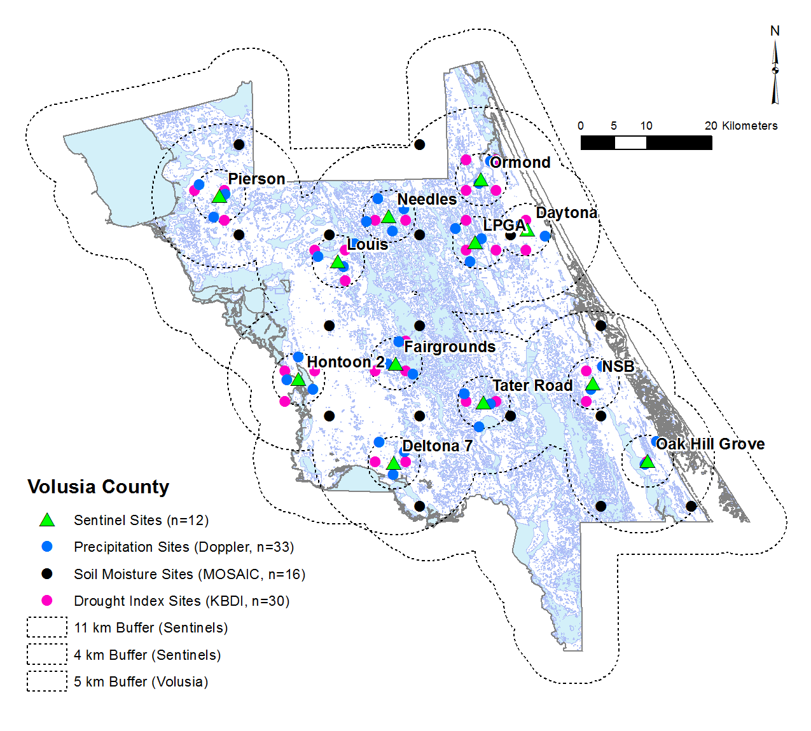

**Figure 1.**

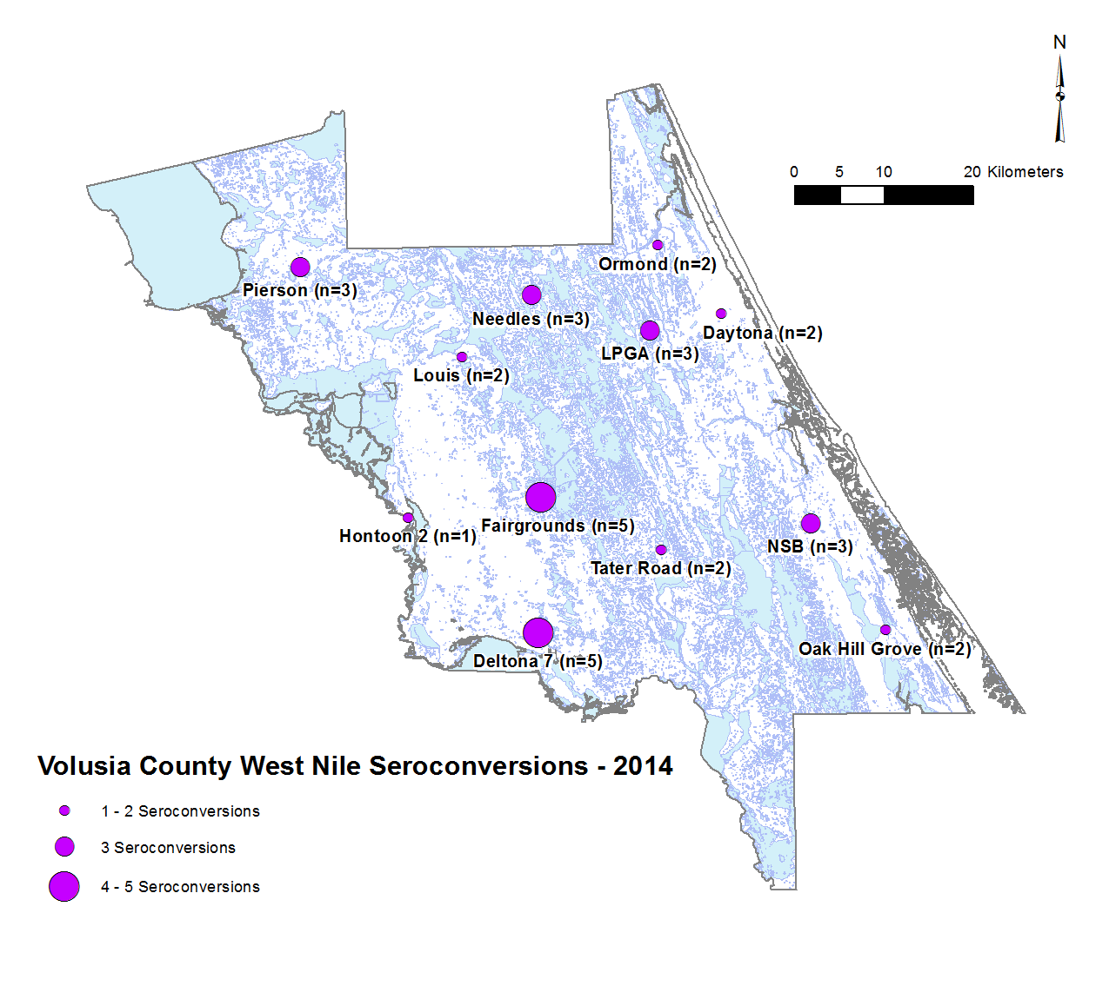

**Figure 2.**

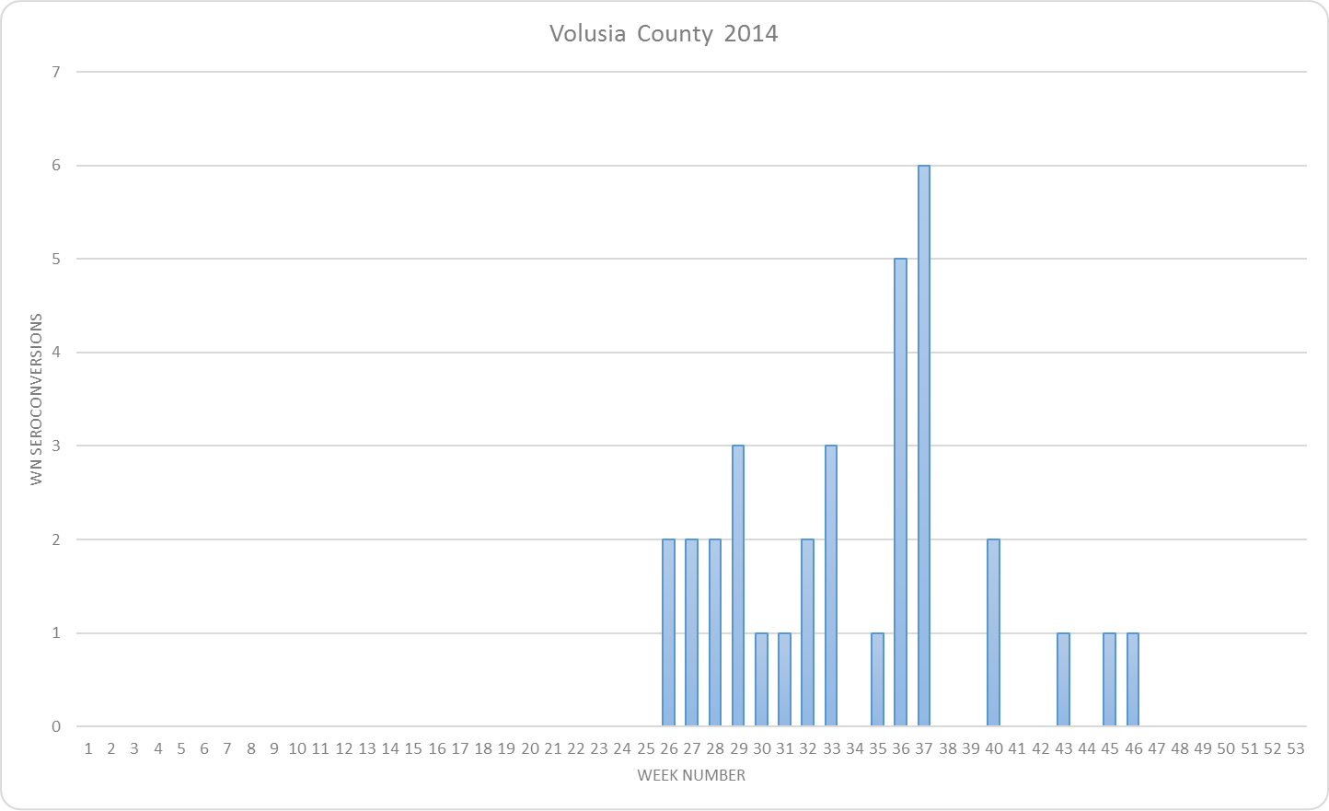

**Figure 3.**

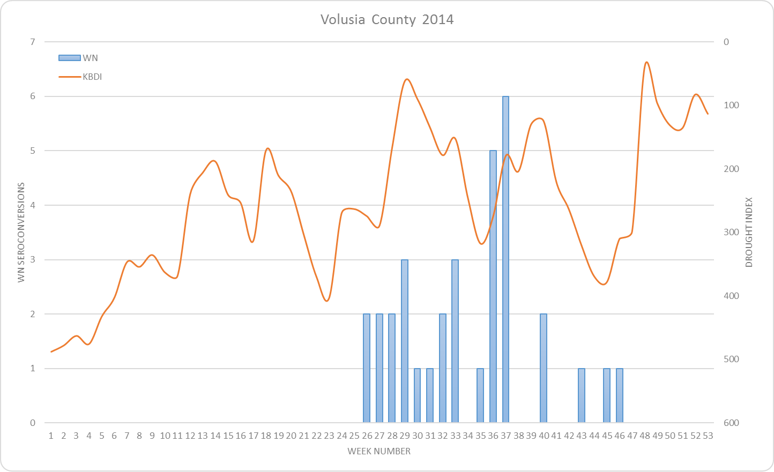

**Figure 4.**

**Figure 5.**

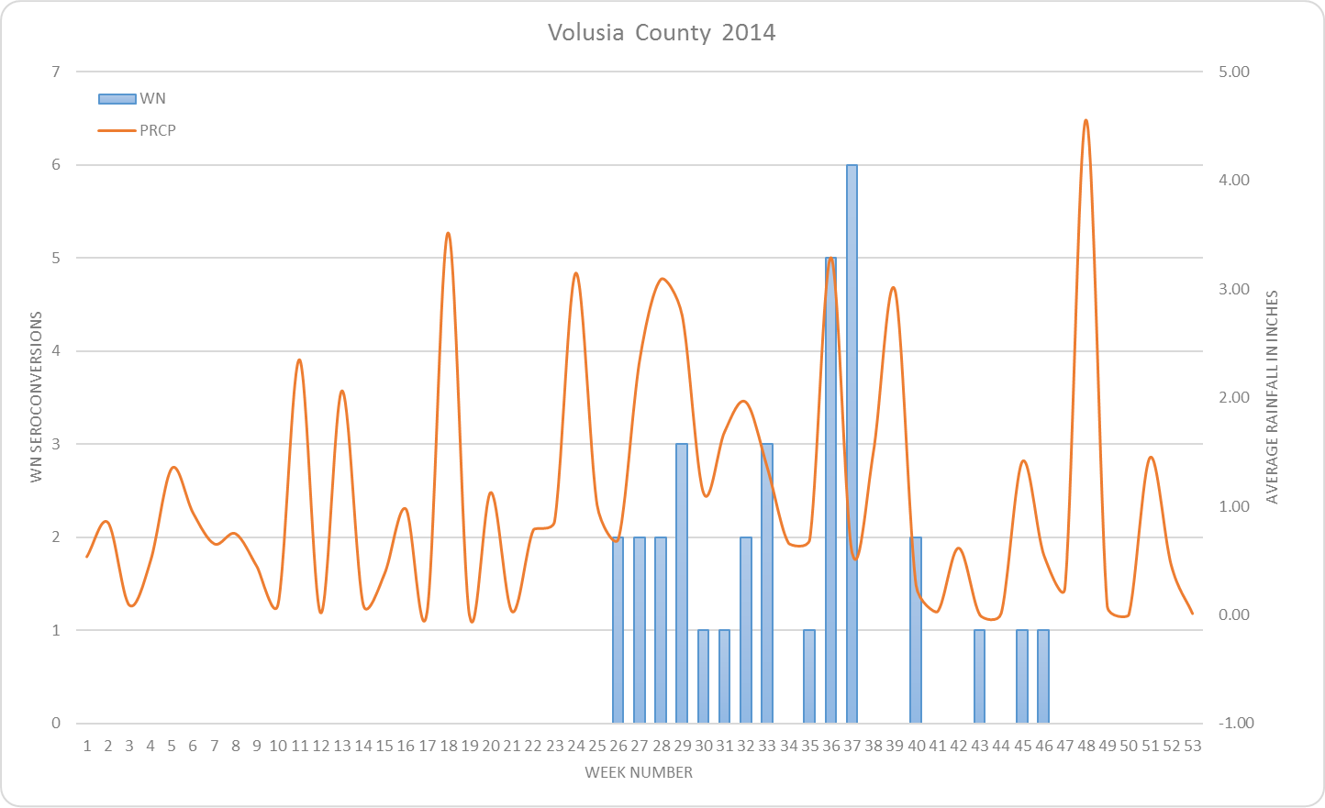

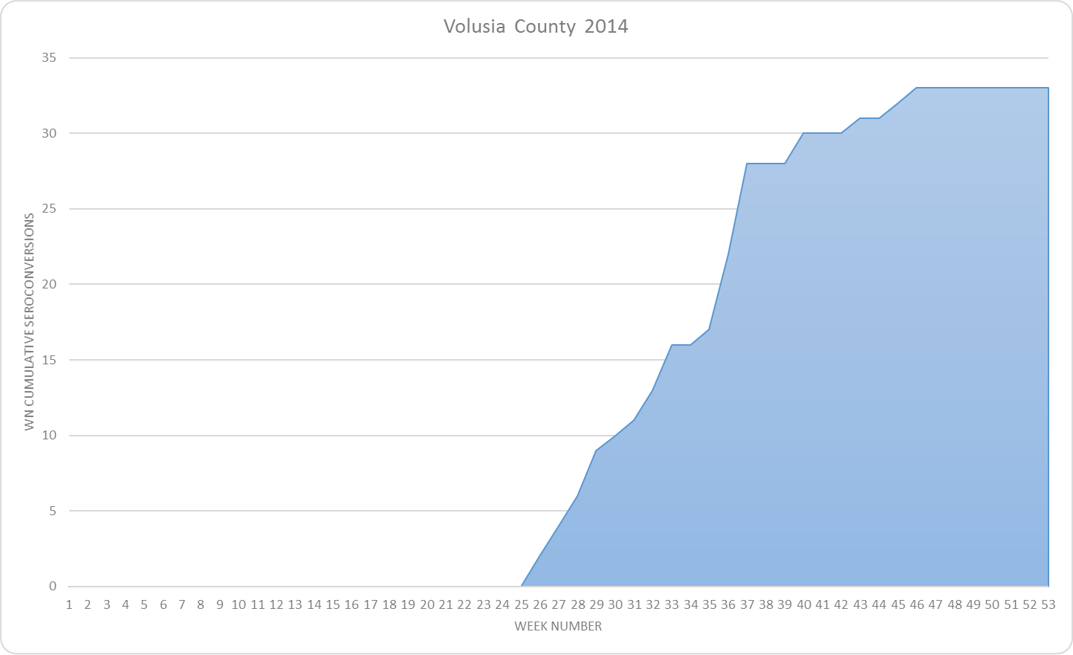

**Figure 6.**

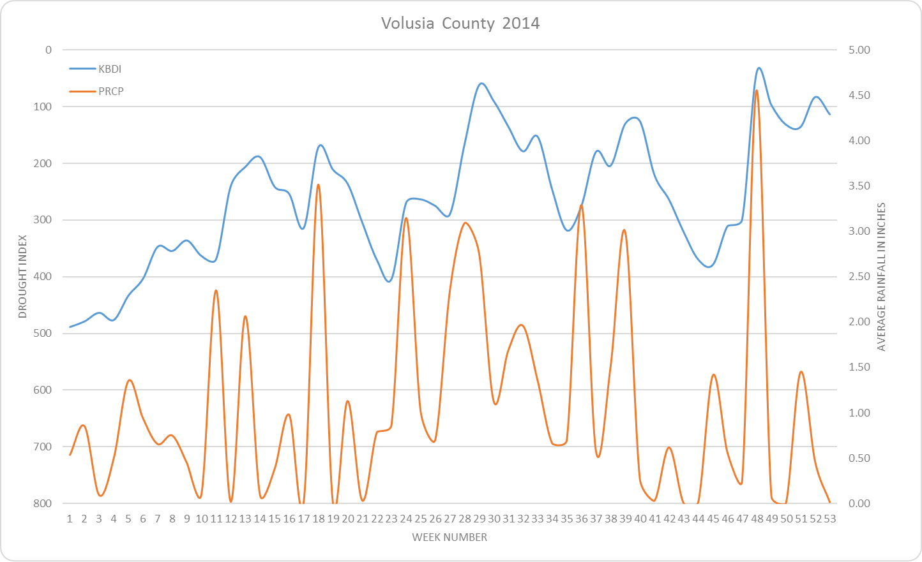

**Figure 7.**

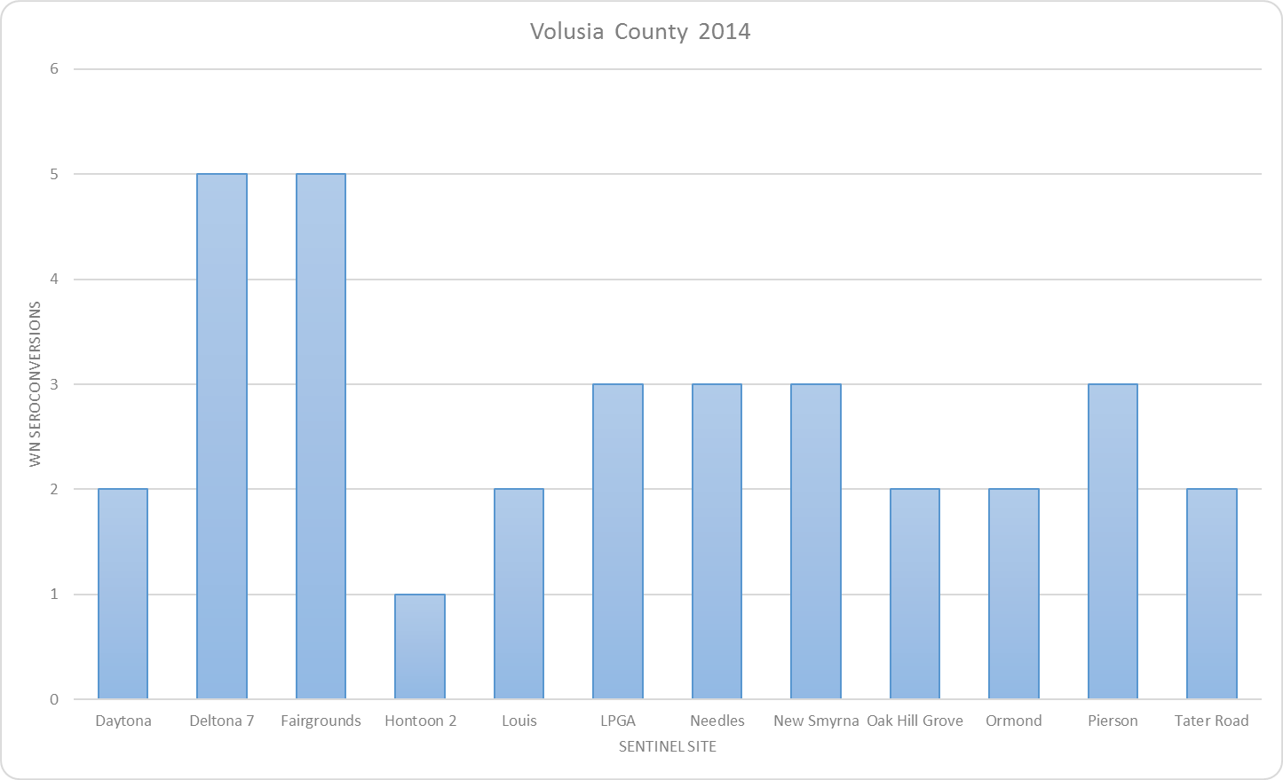

**Figure 8.**

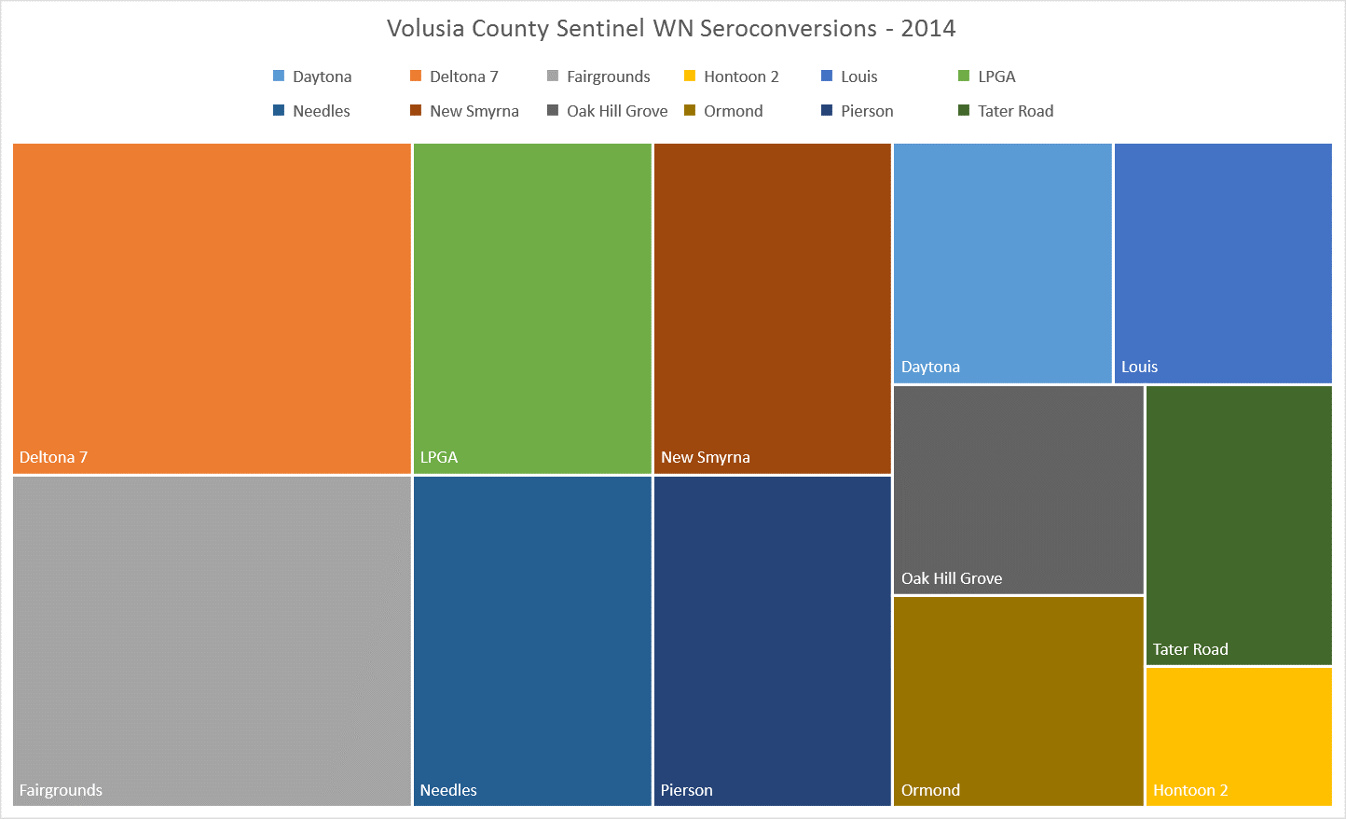

**Figure 9.**